SCUBA-2 Block Specification
fsfb_ctrl

Revision History:
Rev. 1.0 MN Initial Release
Rev. 1.1 MA added document number and revision history

September 15, 2006
Table of Contents

1. Block Overview 3
1.1 Block Location and Block Interface within System 3
1.2 Block Functionality / Features 3
1.3 Block Dataflow 4
2. Block Interfaces 5
2.1 Interface Signal Description 5
2.2 Interface Protocol and Timing 5
3. High-Level Description 7
3.1 State Machine Descriptions 7
3.2 Special Optimizations 8
4. Files of the Block 9
4.1 Source Code 9
4.1.1 Source1.vhd 9
4.2 Header Code 9
4.2.1 Header1.vhd 9
5. Naming Conventions Used 10

Block Overview

Block Location and Block Interface within System
The fsfb_ctrl is a component in flux_loop_ctrl. The flux_loop_ctrl is instantiated eight times, one per channel, in the flux_loop block of a Readout Card.
As illustrated in Figure 1, the fsfb_ctrl interfaces with the following blocks:
- The DAC of the Readout card;
- The frame_timing block on the Readout card;
- The fsfb_calc in the flux_loop_ctrl.

DAC
frame_timing
fsfb_ctrl
flux_loop_ctrl
fsfb_calc
Figure 1: Location of fsfb_ctrl in the System.

Block Functionality / Features
The fsfb_ctrl block receives the 32-bit data, fsfb_ctrl_dat_i(31..0), to be applied to DAC. Since DAC input data is only 14 bits, fsfb_ctrl selects only 14 bits from the input data, e.g., fsfb_ctrl_dat_i(25..12). The selection is based on a generic value that has a default value of (13..0). If not in lock mode, fsfb_ctrl sends the data as is to the DAC and issues a DAC clock enable signal under the control of dac_dat_en_i from the frame_timing block. However, if it is in lock mode indicated by the fsfb_calc block, fsfb_ctrl runs the input data through a conversion map. The conversion map is to convert the input 2’s complement to a binary output. This conversion map needs to know the polarity of conversion in the ADC. This latter information is provided to fsfb_ctrl using a generic value. Finally, the converted data is sent to the DAC and a DAC clock is asserted under the control of the dac_dat_en_i from the frame_timing block.

Block Dataflow
Figure 2 represents the dataflow for fsfb_ctrl.

Conversion Map
From fsfb_calc
fsfb_ctrl_lock_en_i
To DAC
F
F
F
F
fsfb_ctrl_dat_rdy_i
enb
Figure 2: The fsfb_ctrl block dataflow.

Block Interfaces

Interface Signal Description
- Interface Signals
Signal | Description | Direction
Global Signals
rst_i | Global reset | in
clk_50_i | Global clock | in
Frame_timing Interface
dac_dat_en_i | Indicates the window to send data to the DAC | in
fsfb_calc Interface
fsfb_ctrl_dat_i | Input data from upstream block | in
fsfb_ctrl_dat_rdy_i | Asserted for one clock cycle when the data input is valid | in
fsfb_ctrl_lock_en_i | When high, it indicates that the flux_loop_ctrl is in lock mode | in
DAC Interface
dac_dat_o | Data to the DAC | out
dac_clk_o | Enable clock to DAC | out

Interface Protocol and Timing
Figure 3 illustrates the interface protocol timing.

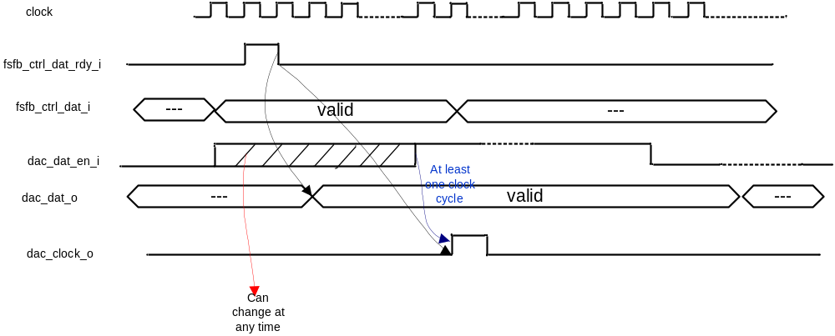
Figure 3: Timing for Interface Signals.
As shown in Figure 3, dac_dat_en_i can change at any time with respect to fsfb_ctrl_dat_rdy_i. Therefore, dac_clock_o is asserted if both fsfb_ctrl_dat_rdy_i and dac_dat_en_i have been asserted.

High-Level Description

State Machine Descriptions
The Algorithmic State Machine (ASM) for the fsfb_ctrl is shown in Figure 4.

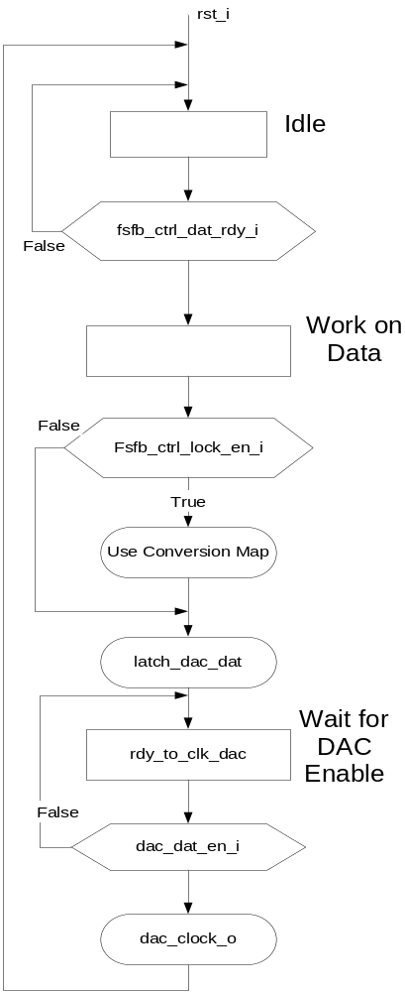
Figure 4: The fsfb_ctrl Algorithmic State Machine.

A timing diagram representation of the control signals for the fsfb_ctrl is shown in Figure 5.

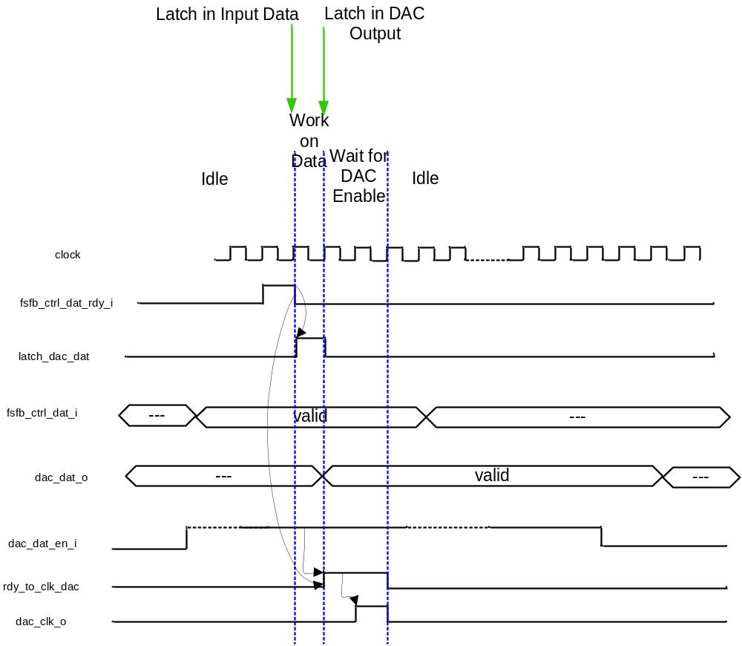
Figure 5: The fsfb_ctrl Control Signals Timing.

Conversion Map
As seen in Figure 2, the data from fsfb_calc is passed through a conversion map. The values from fsfb_calc are either negative or positive and range between –n to +n. However DAC is unipolar, and, hence, DAC value need to vary between 0 to N. Moreover, a positive change in the circuitry connected to the ADC can result in a negative or positive value at the output of the ADC. The DAC output needs to compensate for the change at the input of the ADC. Therefore, the following scenarios are possible:
Straight Polarity
In this case, a positive change in the circuitry connected to the ADC input results in a positive ADC value. Therefore, (-n..+n) from fsfb_calc needs to map to (0..N) in DAC. To achieve this, one could add |n| to the fsfb_calc value. However, a closer analysis reveals that a simple inversion of fsfb_calc most significant bit will result in the correct conversion.
Reverse Polarity
In this case, a positive change in the circuitry connected to the ADC input results in a negative ADC value, and vice versa. Therefore, (-n..+n) from fsfb_calc needs to map to (N..0) in DAC. To achieve this, one could subtract |n-1| from the fsfb_calc value and then convert the sign. As an example, an input value of -6 (4-bit representation) would map to |-6-7|=13. As another example, an input value of 2 would map to –(2-7)=5. However, a closer analysis reveals that a simple inversion of the all the fsfb_calc bits except for the most significant bit will result in the correct conversion.

Special Optimizations

Files of the Block

Source Code

Source1.vhd

Header Code

Header1.vhd

Naming Conventions Used

